Task 1: Array vs Linked List
An array stores its elements in one continuous block of memory, so the address of element *i* is computed directly from the base address. A linked list stores each element in a separate node that holds the value and a pointer to the next node, so nodes can be anywhere in memory.
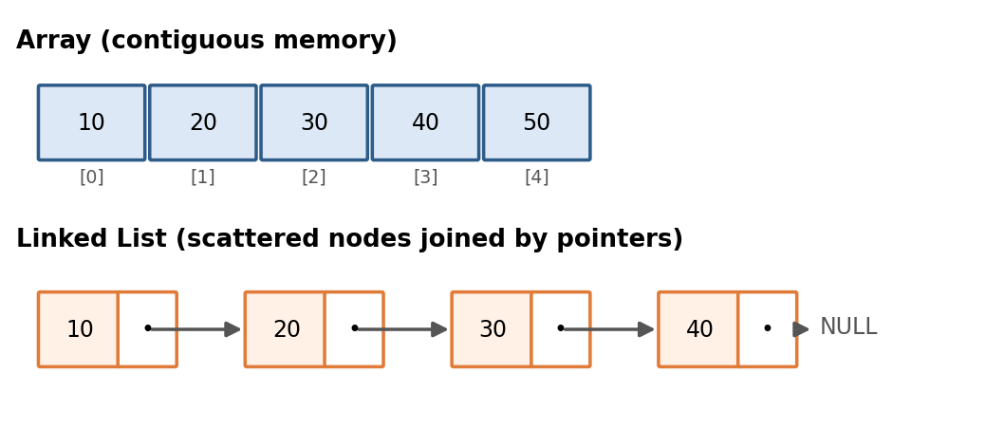
Figure 2. Array (contiguous) versus linked list (pointer-connected nodes)
Criterion | Array | Linked List
Memory layout | Contiguous block | Scattered nodes linked by pointers
Access by index | O(1) | O(n): must walk from the head
Search (unsorted) | O(n) | O(n)
Insert/delete at beginning | O(n): elements shift | O(1)
Insert/delete at end | O(1) amortized (dynamic array) | O(1) with a tail pointer (O(n) to delete in a singly list)
Insert/delete in middle | O(n) shifting | O(1) once the node is found, O(n) to find it
Extra memory | None per element | One or two pointers per node
Cache performance | Excellent (locality) | Poor (pointer chasing)
Size | Fixed, or resized by copying | Grows and shrinks freely

Use cases. Arrays suit lookup tables, matrices, image pixels and anything that needs fast random access. Linked lists suit undo histories, LRU caches, music playlists and the adjacency lists of graphs, where frequent insertions and deletions happen.

Task 2: Static Array vs Dynamic Array
A static array has a size fixed when it is created (for example int a[10] in C). A dynamic array (Python list, C++ vector, Java ArrayList) starts with a small capacity and, when it becomes full, allocates a larger block (usually double), copies the old elements and frees the old block. This resizing costs O(n), but because it happens rarely, appending is amortized O(1): after n appends the total copying work is at most about 2n.

Criterion | Static Array | Dynamic Array
Size | Fixed at creation | Grows/shrinks at run time
Memory allocation | Stack or static memory (fast) | Heap (with resizing overhead)
Append | Not possible when full | O(1) amortized, O(n) when resizing
Access by index | O(1) | O(1)
Wasted space | Possible if oversized | Up to 50% spare capacity
Risk | Overflow if undersized | Occasional latency spike on resize

class DynamicArray:
"""Minimal dynamic array that doubles its capacity when full."""
def __init__(self):
self.capacity, self.size = 2, 0
self.data = [None] * self.capacity

def append(self, value):
if self.size == self.capacity: # full -> grow
self._resize(2 * self.capacity)
self.data[self.size] = value
self.size += 1

def _resize(self, new_cap):
new_data = [None] * new_cap
for i in range(self.size): # O(n) copy, but rare
new_data[i] = self.data[i]
self.data, self.capacity = new_data, new_cap

Task 3: Singly, Doubly and Circular Linked Lists
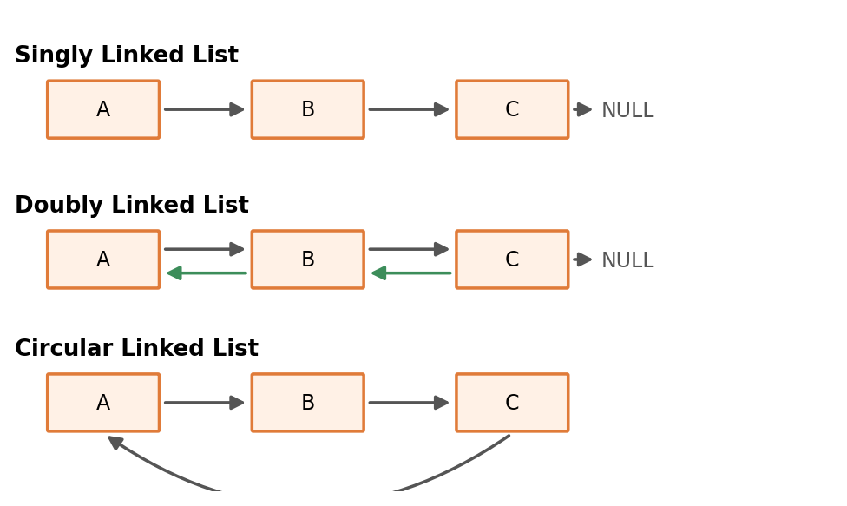
Figure 3. Singly, doubly and circular linked lists
In a singly linked list each node points only to the next node, so traversal is one-directional. A doubly linked list adds a *prev* pointer so it can be traversed both ways. In a circular linked list the last node points back to the

Criterion | Singly | Doubly | Circular
Pointers per node | 1 (next) | 2 (next, prev) | 1 or 2; last links to first
Traversal | Forward only | Forward and backward | Endless loop around the ring
Delete a given node | O(n): need previous node | O(1) | O(n) singly / O(1) doubly
Insert at head/tail | O(1) / O(1) with tail | O(1) / O(1) | O(1) / O(1) with tail pointer
Memory | Lowest | Highest | Same as its base type
Typical use | Stacks, simple queues | Browser history, editors | Round-robin scheduling, playlists

class Node:
def __init__(self, data):
self.data, self.next = data, None

class SinglyLinkedList:
def __init__(self): self.head = None
def push_front(self, x): # O(1)
n = Node(x); n.next = self.head; self.head = n
def find(self, x): # O(n)
cur = self.head
while cur and cur.data != x: cur = cur.next
return cur

Task 4: Stack vs Queue
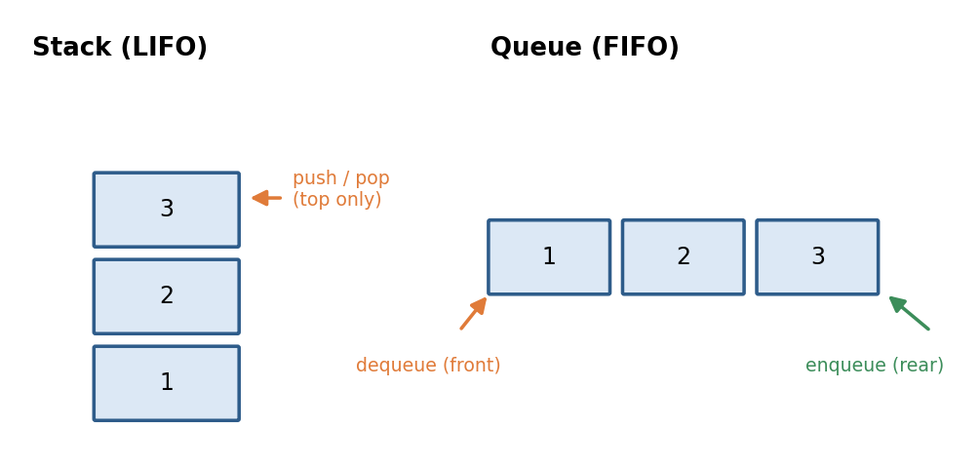
Figure 4. Stack (LIFO) and queue (FIFO)
A stack follows Last-In-First-Out (LIFO): elements are added and removed at the same end (the top). A queue follows First-In-First-Out (FIFO): elements are added at the rear and removed from the front.
Criterion | Stack | Queue
Principle | LIFO | FIFO
Main operations | push, pop, peek | enqueue, dequeue, front
Access points | One end (top) | Two ends (front and rear)
All operations | O(1) | O(1) with a linked list or circular buffer
Typical uses | Undo/redo, function calls, bracket matching, DFS | Task scheduling, printer jobs, BFS, message buffers
Real example | Browser back button | Customers waiting at a bank

from collections import deque
stack = []; stack.append(1); stack.append(2); top = stack.pop() # top == 2
queue = deque(); queue.append(1); queue.append(2); first = queue.popleft() # 1
# Note: list.pop(0) is O(n), so deque is used for queues.

Task 5: Stack vs Recursion
A stack is a data structure. Recursion is a programming technique in which a function calls itself on a smaller version of the problem until it reaches a base case. They are related because recursion is implemented with a stack: each call pushes a *stack frame* (parameters, local variables, return address) onto the call stack, and each return pops it. Any recursive algorithm can be rewritten as a loop with an explicit stack.
Criterion | Stack | Recursion
Nature | Data structure (LIFO container) | Technique / control flow
Who manages memory | Programmer (explicit stack) | Runtime call stack (implicit)
Depth limit | Limited by heap memory | Limited by call-stack size (Python default about 1000 frames)
Failure mode | Out of memory | Stack overflow / RecursionError
Readability | More code | Short and natural for trees, divide and conquer
Overhead | Low | Function-call overhead per level

def dfs_recursive(g, u, seen): # implicit call stack
seen.add(u)
for v in g[u]:
if v not in seen: dfs_recursive(g, v, seen)

def dfs_iterative(g, start): # explicit stack
seen, stack = set(), [start]
while stack:
u = stack.pop()
if u in seen: continue
seen.add(u)
stack.extend(v for v in g[u] if v not in seen)
return seeTask 6: Queue vs Priority Queue
A normal queue serves elements strictly in arrival order. A priority queue serves the element with the highest priority first, regardless of arrival time; equal priorities are usually served in arrival order or arbitrarily. It is typically implemented with a binary heap.
Criterion | Queue | Priority Queue
Order of removal | Insertion order (FIFO) | By priority (min or max first)
Enqueue | O(1) | O(log n) with binary heap
Dequeue | O(1) | O(log n) with binary heap
Peek front/top | O(1) | O(1)
Typical implementation | Circular array or linked list | Binary heap
Uses | BFS, buffering, print jobs | Dijkstra, OS scheduling, event simulation, Huffman coding

import heapq
pq = []
heapq.heappush(pq, (2, "write report"))
heapq.heappush(pq, (1, "fix server crash")) # lower number = higher priority
heapq.heappush(pq, (3, "reply to email"))
print(heapq.heappop(pq)) # (1, 'fix server crash')

Task 7: Linear vs Non-Linear Data Structures
In a linear data structure the elements form a sequence: each element has at most one predecessor and one successor, and they can be traversed in a single pass (array, linked list, stack, queue). In a non-linear data structure an element can be connected to several others, forming a hierarchy or a network (tree, graph, heap, trie).
Criterion | Linear | Non-Linear
Arrangement | Sequential | Hierarchical or networked
Relationships | One-to-one | One-to-many or many-to-many
Traversal | Single pass, one run | Needs BFS/DFS or level/in-order traversal
Memory use | Simple, often contiguous | More complex, pointer-based
Levels | Single level | Multiple levels
Examples | Array, list, stack, queue | Tree, graph, heap, trie
Best for | Ordered collections | Hierarchies, networks, fast search by structure

Task 8: Tree vs Graph

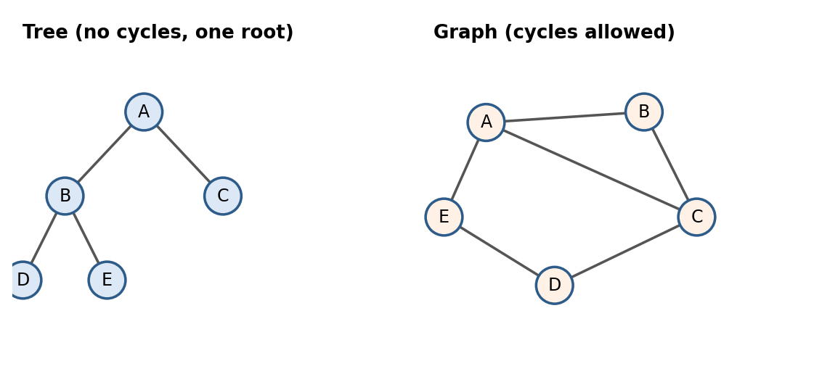
Figure 5. A tree (left) and a graph containing cycles (right)
A tree is a connected, acyclic structure with a designated root; every node except the root has exactly one parent, and a tree with n nodes always has n-1 edges. A graph is a more general set of vertices and edges: it may be directed or undirected, weighted or unweighted, connected or disconnected, and it may contain cycles. Every tree is a graph, but not every graph is a tree.
Criterion | Tree | Graph
Cycles | Never | Allowed
Root | Exactly one | None required
Edges | Exactly n-1 | Any number, up to n(n-1)/2 (undirected)
Parents per node | One | Any number of neighbours
Connectivity | Always connected | May be disconnected
Traversal | Pre/in/post-order, level-order | BFS, DFS (need a visited set)
Examples | File system, HTML DOM, org chart | Road network, social network, internet

Task 9: Binary Tree vs Binary Search Tree (BST)
A binary tree is any tree in which each node has at most two children (left and right), with no rule about the values. A binary search tree is a binary tree with an ordering invariant: for every node, all values in the left subtree are smaller and all values in the right subtree are larger. This invariant allows fast search, and an in-order traversal of a BST visits keys in sorted order.
Criterion | Binary Tree | Binary Search Tree
Ordering rule | None | Left < node < right
Search | O(n) | O(log n) avg, O(n) worst (skewed)
Insert | O(1) at a free position, or O(n) to find one | O(log n) avg, O(n) worst
In-order traversal | Arbitrary order | Sorted order
Duplicates | Allowed | Usually disallowed or handled by a rule
Uses | Expression trees, Huffman trees, heaps | Ordered sets/maps, dictionaries, range queries

class BSTNode:
def __init__(self, key): self.key, self.left, self.right = key, None, None

def insert(root, key):
if root is None: return BSTNode(key)
if key < root.key: root.left = insert(root.left, key)
elif key > root.key: root.right = insert(root.right, key)
return root

def search(root, key):
while root and root.key != key:
root = root.left if key < root.key else root.right
return root is not None

def inorder(root): # yields keys in sorted order
if root: yield from inorder(root.left); yield root.key; yield from inorder(root.right)
A weakness of the plain BST is that inserting already sorted keys (1, 2, 3, ...) produces a chain that behaves like a linked list with O(n) operations. Task 11 shows how AVL trees fix this.

Task 10: BST vs Heap
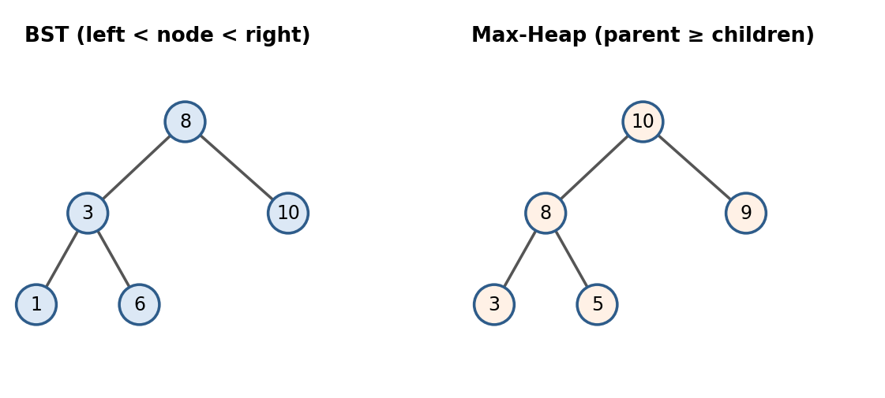
Figure 6. A BST (left) and a max-heap (right) storing similar values
Both are binary trees but they order data differently. A BST orders left to right, so any key can be found quickly. A heap orders top to bottom: in a max-heap every parent is greater than or equal to its children, so the largest element is always at the root, but there is no order between siblings. A heap is also a *complete* binary tree, which allows it to be stored compactly in an array (children of index i at 2i+1 and 2i+2).
Criterion | BST | Binary Heap
Ordering | Left < node < right | Parent ≥ (or ≤) children
Shape | Any (balanced or skewed) | Always complete
Storage | Nodes with pointers | Plain array
Find arbitrary key | O(log n) avg | O(n)
Find min / max | O(log n) avg (leftmost / rightmost) | O(1) at the root
Insert | O(log n) avg | O(log n) worst
Delete min/max | O(log n) avg | O(log n) worst
Sorted traversal | O(n) via in-order | O(n log n) via repeated extraction
Best for | Searching, ordered data, ranges | Priority queues, top-k, heap sort

Task 11: AVL Tree vs BST
An AVL tree (Adelson-Velsky and Landis, 1962) is a self-balancing BST. It keeps, for every node, a *balance factor* = height(left) - height(right) in {-1, 0, +1}. When an insertion or deletion breaks this rule, the tree repairs itself using rotations (left, right, left-right, right-left). Consequently its height is always O(log n) (at most about 1.44 log₂ n), whereas an ordinary BST can degrade to height n.

Criterion | Plain BST |  | AVL Tree
Balancing | None |  | Automatic via rotations
Height | O(log n) avg, O(n) worst |  | Always O(log n)
Search | O(log n) avg, O(n) worst |  | O(log n) guaranteed
Insert / delete | O(log n) avg, O(n) worst |  | O(log n) guaranteed (plus rotations)
Extra data per node | None |  | Height or balance factor
Simple |  | More complex
Best for | Small or random data |  | Lookup-heavy workloads needing guaranteed speed

def rotate_right(y):
"""Fix a left-heavy node y: y x
/ / \
x -> a y
/ \ / \
a b b c"""
x = y.left
y.left, x.right = x.right, y
y.height = 1 + max(h(y.left), h(y.right))
x.height = 1 + max(h(x.left), h(x.right))
return x # new subtree root

Task 12: Heap vs Priority Queue
This comparison is between an abstract data type (ADT) and a data structure. A *priority queue* is an ADT: it defines behaviour (insert an item with a priority, remove the item with the highest priority, peek) without saying how it is built. A *heap* is a concrete data structure, usually an array-based binary heap, and is the most popular way to implement a priority queue. A priority queue could also be built with a sorted array, an unsorted list or a balanced BST.
Implementation of a priority queue | Insert | Extract-min | Peek
Unsorted array / list | O(1) | O(n) | O(n)
Sorted array | O(n) | O(1) (if kept in reverse order) | O(1)
Balanced BST (AVL) | O(log n) | O(log n) | O(log n)
Binary heap | O(log n) | O(log n) | O(1)
Fibonacci heap | O(1) amortized | O(log n) amortized | O(1)

Criterion | Heap | Priority Queue
Category | Data structure (implementation) | Abstract data type (interface)
Defines | How data is arranged in memory | What operations are supported
Alternatives | Can be used for heap sort, k-th largest | Can use heap, BST, list or array underneath
Example in Python | Functions in heapq | queue.PriorityQueue (thread-safe wrapper over a heap)

Task 13: Adjacency Matrix vs Adjacency List
Both are ways to store a graph in memory. An adjacency matrix is a V × V table where cell [i][j] is 1 (or the weight) if there is an edge from i to j. An adjacency list stores, for every vertex, a list of its neighbours.
Criterion | Adjacency Matrix | Adjacency List
Space | O(V²) | O(V + E)
Check if edge (u,v) exists | O(1) | O(deg(u))
List neighbours of u | O(V) | O(deg(u))
Add edge | O(1) | O(1)
Remove edge | O(1) | O(deg(u))
Add vertex | O(V²) (rebuild matrix) | O(1)
Traversal (BFS/DFS) | O(V²) | O(V + E)
Best for | Dense graphs, frequent edge queries, Floyd-Warshall | Sparse graphs (most real-world graphs)

edges = [(0,1),(0,2),(1,2),(2,3)]
V = 4
matrix = [[0]*V for _ in range(V)]
adj = {i: [] for i in range(V)}
for u, v in edges: # undirected graph
matrix[u][v] = matrix[v][u] = 1
adj[u].append(v); adj[v].append(u)
# matrix[1][2] -> 1 in O(1); adj[2] -> [0, 1, 3] in O(deg)

Task 14: BFS vs DFS
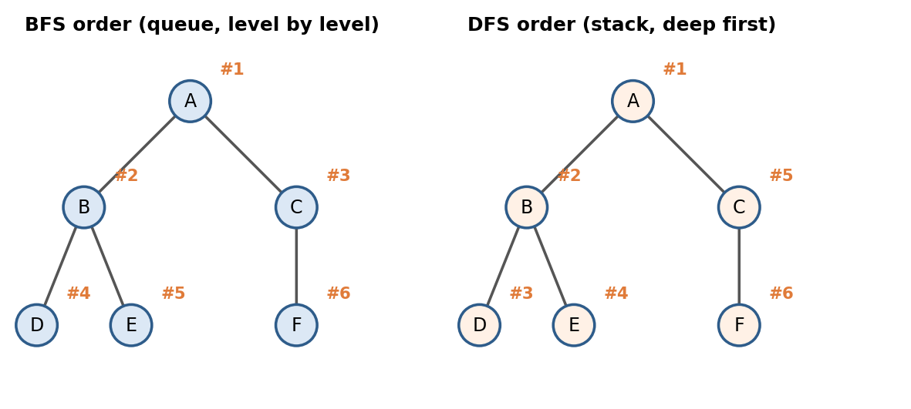
Figure 7. Visiting order of BFS and DFS on the same tree
Breadth-First Search (BFS) explores a graph level by level, visiting all neighbours of a node before going deeper, using a queue. Depth-First Search (DFS) follows one path as far as possible before backtracking, using a stack (or recursion). Both visit every vertex and edge once, so both run in O(V + E) with an adjacency list.
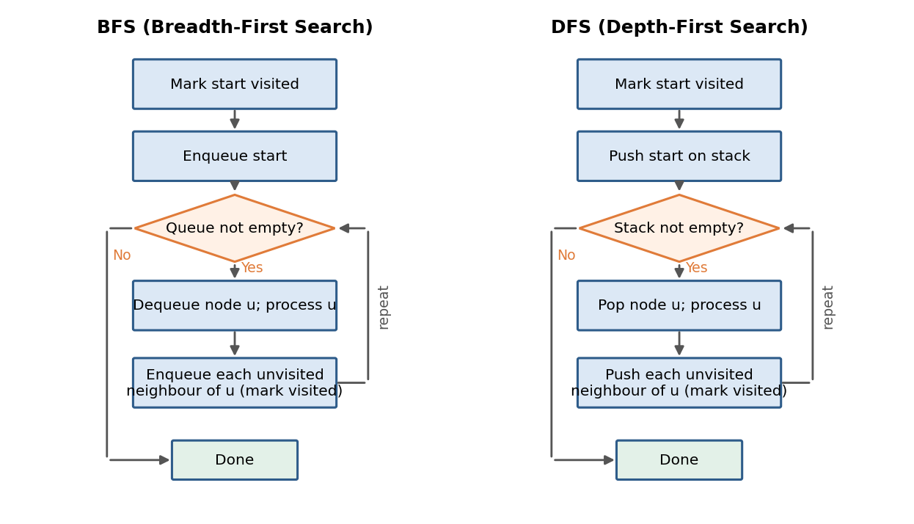
Figure 8. Flow diagrams for BFS (queue) and DFS (stack)
Criterion | BFS | DFS
Data structure | Queue | Stack / recursion
Time | O(V + E) | O(V + E)
Space | O(V) (widest level) | O(V) (deepest path)
Shortest path (unweighted) | Yes, guaranteed | No
Completeness on infinite graphs | Finds a solution if one exists | May go down an infinite branch
Typical uses | Shortest hops, level-order, social network distance, web crawling | Cycle detection, topological sort, connected components, maze solving, backtracking

from collections import deque

def bfs(g, s):
dist, q = {s: 0}, deque([s])
while q:
u = q.popleft()
for v in g[u]:
if v not in dist:
dist[v] = dist[u] + 1 # number of edges from s
q.append(v)
return dist

def dfs(g, u, seen=None):
seen = seen if seen is not None else set()
seen.add(u)
for v in g[u]:
if v not in seen: dfs(g, v, seen)
return seen

Task 15: Linear Search vs Binary Search
Linear search checks every element one by one until it finds the target or reaches the end; it works on any list, sorted or not. Binary search repeatedly halves a sorted array, comparing the target to the middle element and discarding the half that cannot contain it. Binary search requires the data to be sorted.
Criterion | Linear Search | Binary Search
Precondition | None | Array must be sorted
Time (worst) | O(n) | O(log n)
Time (best) | O(1) | O(1)
Space | O(1) | O(1) iterative, O(log n) recursive
Works on linked list | Yes | Not efficiently (no random access)
Use case | Small or unsorted data | Large sorted data, dictionaries, indexes

def linear_search(a, target):
for i, x in enumerate(a):
if x == target: return i
return -1

def binary_search(a, target):
lo, hi = 0, len(a) - 1
while lo <= hi:
mid = (lo + hi) // 2
if a[mid] == target: return mid
if a[mid] < target: lo = mid + 1
else: hi = mid - 1
return -1

Task 16: Sorting Algorithms — Time Complexity
Sorting algorithms differ in how they compare and move elements. The table below summarises the standard comparison-based and non-comparison algorithms.
Algorithm | Best | Average | Worst | Space | Stable?
Bubble Sort | O(n) | O(n²) | O(n²) | O(1) | Yes
Selection Sort | O(n²) | O(n²) | O(n²) | O(1) | No
Insertion Sort | O(n) | O(n²) | O(n²) | O(1) | Yes
Merge Sort | O(n log n) | O(n log n) | O(n log n) | O(n) | Yes
Quick Sort | O(n log n) | O(n log n) | O(n²) | O(log n) | No
Heap Sort | O(n log n) | O(n log n) | O(n log n) | O(1) | No
Counting Sort | O(n + k) | O(n + k) | O(n + k) | O(n + k) | Yes
Radix Sort | O(d·(n+k)) | O(d·(n+k)) | O(d·(n+k)) | O(n + k) | Yes

Here n is the number of elements, k is the range of key values (for counting sort) and d is the number of digits (for radix sort). Comparison-based sorts can never beat O(n log n) in the worst case (an information-theoretic lower bound); counting and radix sort escape this bound because they don't compare elements directly, at the cost of needing a bounded key range.

Task 17: Quick Sort vs Merge Sort
Both are O(n log n) divide-and-conquer sorts, but they divide the work differently. Quick Sort partitions the array around a pivot so that smaller elements go left and larger go right, then recursively sorts each side; most of the work happens *before* the recursive calls (partitioning), and it sorts in place. Merge Sort splits the array in half blindly, recursively sorts each half, and then merges the two sorted halves; most of the work happens *after* the recursive calls (merging), and it needs an auxiliary array.
Criterion | Quick Sort | Merge Sort
Strategy | Partition around a pivot | Split in half, then merge
Worst case | O(n²) (bad pivot, e.g. sorted input with first-element pivot) | O(n log n) guaranteed
Average case | O(n log n), small constant factor | O(n log n)
Space | O(log n) (recursion stack, in-place) | O(n) (extra merge buffer)
Stability | Not stable (can be made stable with extra memory) | Stable
Cache behaviour | Very good (in-place, local) | Good but needs extra copying
Best for | In-memory arrays, general use | Linked lists, external sorting, when stability is required

def quicksort(a, lo=0, hi=None):
if hi is None: hi = len(a) - 1
if lo < hi:
p = partition(a, lo, hi)
quicksort(a, lo, p - 1); quicksort(a, p + 1, hi)
return a

def partition(a, lo, hi):
pivot = a[hi]; i = lo - 1
for j in range(lo, hi):
if a[j] <= pivot:
i += 1; a[i], a[j] = a[j], a[i]
a[i+1], a[hi] = a[hi], a[i+1]
return i + 1

def mergesort(a):
if len(a) <= 1: return a
m = len(a) // 2
left, right = mergesort(a[:m]), mergesort(a[m:])
merged, i, j = [], 0, 0
while i < len(left) and j < len(right):
if left[i] <= right[j]: merged.append(left[i]); i += 1
else: merged.append(right[j]); j += 1
return merged + left[i:] + right[j:]

Task 18: Stable vs Unstable Sorting Algorithms
A sort is stable if it preserves the original relative order of elements that compare equal. This matters when records carry extra information beyond the sort key — for example, sorting students by grade should not shuffle two students who already had the same grade in name order from a previous sort.

Aspect | Stable Sort | Unstable Sort
Equal-key order | Preserved | Not guaranteed
Examples | Merge Sort, Insertion Sort, Bubble Sort, Counting Sort, Timsort | Quick Sort, Heap Sort, Selection Sort
Typical fix if needed | None needed | Sort by (key, original_index) as a tie-breaker
Common use | Multi-key sorts (sort by date, then by name) | When only the final key order matters

students = [("Ali", 90), ("Sara", 85), ("Omar", 90)]
# Stable sort keeps Ali before Omar since both have 90 and Ali came first
by_grade = sorted(students, key=lambda s: -s[1]) # Python's sort (Timsort) is stable

Task 19: Hash Table vs Array
An array maps a small integer index directly to a memory slot. A hash table maps an arbitrary key (a string, tuple, object) to a slot by passing it through a hash function, which lets it offer array-like O(1) average access for keys that are not simple sequential integers.
Criterion | Array | Hash Table
Key type | Integer index only | Any hashable key (string, number, tuple)
Access | O(1), by position | O(1) average, O(n) worst (many collisions)
Order preserved | Yes (by index) | No (unordered, unless a variant tracks insertion order)
Memory | Exactly n slots | n slots plus load-factor overhead and collision handling
Iteration in order | Natural | Needs sorting or an auxiliary ordered structure
Use case | Ordered sequences, matrices | Dictionaries, caches, sets, database indexes

Task 20: Open Hashing vs Closed Hashing
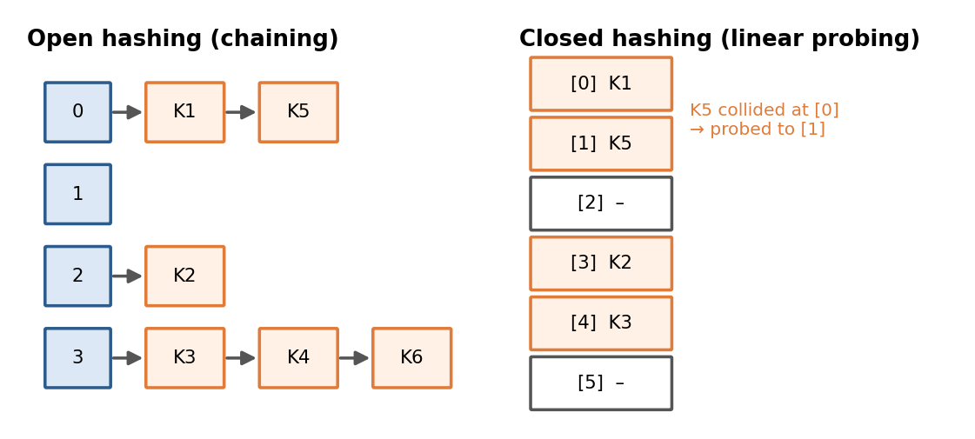
Figure 9. Open hashing (chaining) versus closed hashing (linear probing)
Both are strategies for resolving collisions — when two keys hash to the same slot. Open hashing (separate chaining) stores a small list (or tree) of all keys that hash to the same slot; the table itself is an array of lists. Closed hashing (open addressing) keeps exactly one key per slot and, on a collision, probes for another empty slot in the same array using a rule such as linear probing, quadratic probing, or double hashing.
Criterion | Open Hashing (Chaining) | Closed Hashing (Open Addressing)
Storage | Array of linked lists / buckets | Single array, one key per slot
Load factor > 1? | Allowed (chains grow) | Not allowed (table can fill up)
Memory overhead | Extra pointers per entry | No extra pointers, but needs free slots
Deletion | Simple (remove from chain) | Tricky (needs tombstone markers)
Cache performance | Worse (pointer chasing) | Better (probes stay in the array)
Worst case | O(n) if all keys collide into one chain | O(n) with clustering
Used by | Java HashMap (bucket + tree for large buckets) | Python dict, open-addressing hash sets

Task 21: Shortest Path Algorithms — BFS, Dijkstra, Bellman-Ford, Floyd-Warshall
These four algorithms all find shortest paths in a graph, but they apply to different situations depending on whether edges are weighted and whether negative weights are allowed.
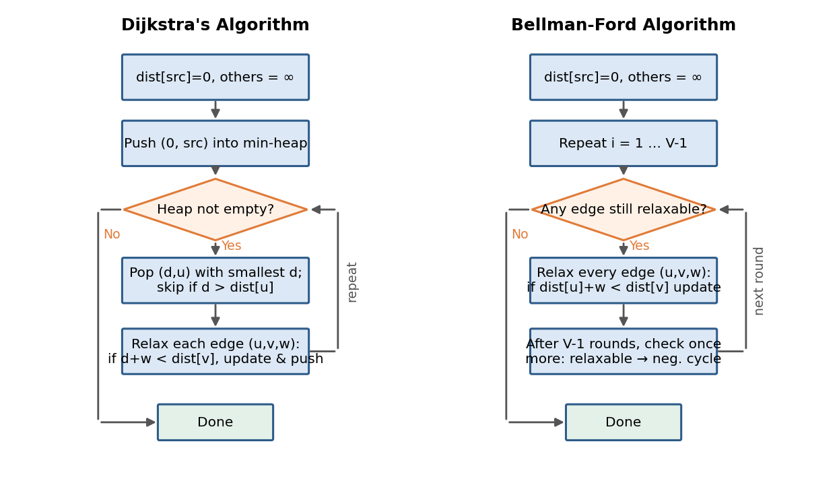
Figure 10. Flow diagrams for Dijkstra's algorithm and Bellman-Ford
Algorithm | Graph type | Handles negative weights? | Scope | Time complexity
BFS | Unweighted | N/A (no weights) | Single-source | O(V + E)
Dijkstra | Weighted, non-negative | No | Single-source | O((V + E) log V) with a min-heap
Bellman-Ford | Weighted, any sign | Yes (and detects negative cycles) | Single-source | O(V · E)
Floyd-Warshall | Weighted, any sign (no negative cycles) | Yes | All-pairs | O(V³)

import heapq
def dijkstra(graph, src): # graph[u] = [(v, weight), ...]
dist = {src: 0}; pq = [(0, src)]
while pq:
d, u = heapq.heappop(pq)
if d > dist.get(u, float("inf")): continue
for v, w in graph[u]:
nd = d + w
if nd < dist.get(v, float("inf")):
dist[v] = nd; heapq.heappush(pq, (nd, v))
return dist

def bellman_ford(V, edges, src): # edges = [(u, v, w), ...]
dist = {v: float("inf") for v in range(V)}; dist[src] = 0
for _ in range(V - 1):
for u, v, w in edges:
if dist[u] + w < dist[v]: dist[v] = dist[u] + w
for u, v, w in edges: # one extra pass detects negative cycles
if dist[u] + w < dist[v]: raise ValueError("Negative-weight cycle")
return dist

Task 22: Single-Source vs All-Pairs Shortest Path Algorithms
A single-source algorithm computes the shortest distance from one starting vertex to every other vertex (BFS, Dijkstra, Bellman-Ford). An all-pairs algorithm computes the shortest distance between every pair of vertices at once (Floyd-Warshall, or running Dijkstra from every vertex, called Johnson's algorithm for sparse graphs).
Criterion | Single-Source | All-Pairs
Output | Distances from one source to all vertices | Distances between every pair of vertices
Typical algorithms | BFS, Dijkstra, Bellman-Ford | Floyd-Warshall, Johnson's algorithm
Time (dense graph) | O(V²) to O((V+E) log V) | O(V³)
Time (sparse, all sources) | V runs of Dijkstra: O(V(V+E) log V) | Johnson: O(V² log V + VE)
When to use | Only one starting point matters (e.g. GPS from current location) | Need a full distance matrix (e.g. precomputed travel-time table)

Task 23: Greedy Algorithms vs Dynamic Programming
Both are strategies for solving optimisation problems by building a solution from smaller pieces. A greedy algorithm makes the locally best choice at each step and never reconsiders it, hoping (and, for the right problems, proving) that local choices lead to a global optimum. Dynamic programming (DP) breaks a problem into overlapping subproblems, solves each subproblem once, stores the result (memoisation or a table), and combines them — exploring, in effect, all relevant choices rather than committing early.

Criterion | Greedy | Dynamic Programming
Decision style | Makes one choice and never revisits it | Considers overlapping subproblems, stores results
Optimality | Only correct where the greedy-choice property + optimal substructure both hold | Always finds the optimum for problems with optimal substructure
Speed | Usually faster, often O(n log n) | Usually slower, e.g. O(n²) or O(n·W)
Memory | Low, no table needed | Needs a table or memo (can be O(n) to O(n²))
Example problems | Huffman coding, Kruskal/Prim MST, activity selection, Dijkstra | 0/1 Knapsack, longest common subsequence, edit distance, matrix chain multiplication
Classic counter-example | Greedy fails on 0/1 Knapsack | DP always works but is heavier

# Greedy: activity selection (choose max number of non-overlapping activities)
def activity_selection(activities): # activities sorted by finish time
count, last_end = 0, float("-inf")
for start, end in activities:
if start >= last_end: count += 1; last_end = end
return count

# DP: 0/1 Knapsack
def knapsack(weights, values, W):
n = len(weights); dp = [[0]*(W+1) for _ in range(n+1)]
for i in range(1, n+1):
for w in range(W+1):
dp[i][w] = dp[i-1][w]
if weights[i-1] <= w:
dp[i][w] = max(dp[i][w], dp[i-1][w-weights[i-1]] + values[i-1])
return dp[n][W]

Task 24: Trie vs Hash Table
A trie (prefix tree) stores strings character by character down a tree; every node represents a prefix shared by all strings below it. A hash table stores each string as a single key mapped to a slot by a hash function. Both can check membership, but a trie also supports fast prefix operations.
Criterion | Trie | Hash Table
Lookup a full key | O(L), L = key length | O(L) to hash + O(1) avg lookup
Prefix search ("all words starting with 'pre'") | O(L + matches) — natural | O(n) — must scan every key
Memory | Can be high (a node per character, though shareable prefixes help) | Compact (buckets + pointers)
Ordering | Alphabetical order available via DFS | No inherent order
Collisions | None (structural, not hashed) | Must be handled (chaining/probing)
Best for | Autocomplete, spell checking, IP routing, dictionaries needing prefixes | General key-value lookup, caches, sets

class TrieNode:
def __init__(self): self.children = {}; self.is_word = False

class Trie:
def __init__(self): self.root = TrieNode()
def insert(self, word):
node = self.root
for ch in word: node = node.children.setdefault(ch, TrieNode())
node.is_word = True
def starts_with(self, prefix): # true if any word has this prefix
node = self.root
for ch in prefix:
if ch not in node.children: return False
node = node.children[ch]
return True

Task 25: Segment Tree vs Fenwick Tree (Binary Indexed Tree)
Both structures answer range queries (e.g. range sum, range minimum) over an array while allowing updates, avoiding the O(n) cost of recomputing from scratch each time. A segment tree is a binary tree where each node stores an aggregate (sum, min, max, gcd, ...) over a sub-range; it can be built for almost any associative operation and supports range updates with lazy propagation. A Fenwick tree (Binary Indexed Tree) is a compact array-based structure, using the binary representation of indices, that supports prefix-sum queries and point updates with very little code and memory — but it is naturally restricted to invertible operations like sums.
Criterion | Segment Tree | Fenwick Tree (BIT)
Memory | About 4n | About n
Build time | O(n) | O(n log n) (or O(n) with a trick)
Point update | O(log n) | O(log n)
Range query | O(log n) | O(log n) (only for prefix/invertible ops)
Range update + range query (lazy) | O(log n) with lazy propagation | Possible but more awkward
Supported operations | Any associative op (sum, min, max, gcd) | Mainly sum / invertible operations
Code complexity | Higher | Lower — a handful of lines

class Fenwick:
def __init__(self, n): self.t = [0]*(n+1)
def update(self, i, delta): # add delta at index i (1-based)
while i < len(self.t): self.t[i] += delta; i += i & (-i)
def prefix_sum(self, i): # sum of a[1..i]
s = 0
while i > 0: s += self.t[i]; i -= i & (-i)
return s
def range_sum(self, l, r): return self.prefix_sum(r) - self.prefix_sum(l - 1)

5.1 Case Studies — Choosing Structures for Real Systems

Case Study 1: Building a search-as-you-type feature
A product-search box needs to suggest matching product names as the user types. A trie built from all product names answers "every product starting with this prefix" in time proportional to the prefix length rather than scanning the whole catalogue, which is exactly the operation a hash table cannot do efficiently (Task 24).

Case Study 2: Routing a delivery fleet
A delivery company models its road network as a weighted graph (Task 8) stored as an adjacency list (Task 13) because the road network is sparse. To find each driver's shortest route from the depot, Dijkstra's algorithm (Task 21) is the right tool, since travel times are never negative; if the company instead needed the shortest travel time between every pair of warehouses, Floyd-Warshall would be used once to precompute the full matrix.

Case Study 3: Undo/redo in a text editor
Every action (type, delete, paste) is pushed onto an undo stack (Task 4); undo pops and reverses the last action, pushing it onto a redo stack. The LIFO order matches exactly how users expect undo to work: the most recent action is reversed first.

Case Study 4: Task scheduler with urgent jobs
An operating system or job runner needs to always run the most urgent pending task next, even if less urgent tasks arrived earlier. A priority queue backed by a binary heap (Tasks 6 and 12) gives O(log n) insertion of new jobs and O(log n) extraction of the most urgent one, with O(1) to peek at what is next.

Case Study 5: Range-sum queries on a stock-price array
An analytics dashboard repeatedly asks "what is the sum of trading volume between day i and day j", while new days are still being appended and old totals corrected. A Fenwick tree (Task 25) supports both the point updates and the range-sum queries in O(log n), far better than recomputing sums with a fresh O(n) pass.

5.2 Performance Analysis
Complexity classes describe *trends*, not exact running times, so the tasks above were paired with a small benchmark, run in this environment on randomly generated data, to make the trends concrete.
n (elements) | Bubble Sort O(n²) | Merge Sort O(n log n) | Quick Sort O(n log n) | Python sorted() (Timsort)
1000 | 29.28 ms | 1.05 ms | 0.79 ms | 0.082 ms
3000 | 268.71 ms | 3.70 ms | 2.78 ms | 0.282 ms

Tripling n from 1,000 to 3,000 multiplies Bubble Sort's time by about 9.2×, consistent with the O(n²) prediction of roughly 3² = 9×, while Merge and Quick Sort's time grows by only about 3.5–3.5×, close to the O(n log n) prediction. Python's built-in sorted() is fastest of all because Timsort is a highly optimised, compiled hybrid of merge and insertion sort.
Search method (200,000 sorted integers) | Time for one lookup | Complexity
Linear search | 4.918 ms | O(n)
Binary search (bisect) | 0.0003 ms | O(log n)
Dict (hash table) lookup | 0.0002 ms | O(1) average

Binary search is roughly 18559× faster than linear search on 200,000 elements, and a hash-table lookup is faster still, matching the O(n) vs O(log n) vs O(1) predictions from Tasks 15 and 19.

5.2.1 Bonus: reproducing the benchmark
The script below (Python 3, standard library only) produced the figures above and can be re-run with larger n to see the trends continue
import random, time, bisect
def timeit(f, *a, rep=3):
best = float("inf")
for _ in range(rep):
t0 = time.perf_counter(); f(*a); best = min(best, time.perf_counter() - t0)
return best * 1000 # milliseconds

random.seed(1)
for n in (1000, 3000):
a = [random.randint(0, 10**6) for _ in range(n)]
print(n, "sorted():", timeit(sorted, a), "ms")

arr = list(range(200_000))
print("binary search:", timeit(bisect.bisect_left, arr, 199_999), "ms")

